[CEN 323 ] Computer Organization & Assembly Language
Lab 5 Journal

Name : Fatima Asad
Enrollment Number: 01-135232-020

Lab Deliverables (submission guideline)

Create a folder named after your enrollment number and add the following files:
  - Create a folder named YourRollNumber_Lab5 containing:
- .asm files of the three practice tasks.
- Add full screen screenshots of the code and output in this word file.
  - Zip the Folder and upload to LMS.

Lab Task

Task 1:
Code (TEXT):
org 1000h

.data

streven db 10,13, "the number was even $"
strodd db 10,13, "the number was odd $"
A db ?
.code

mov ah, 1
int 21h
mov ah, 0
mov bl, 2
div bl
cmp ah,0
je even
mov ah, 9
LEA dx,strodd
int 21h
jmp e
even:
mov ah, 9
LEA dx,streven
int 21h

e:

Screenshot (CODE):
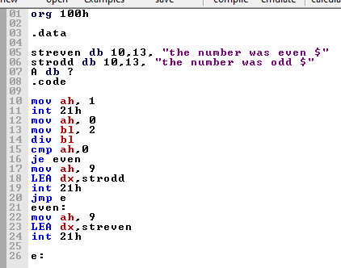

Screenshot (OUTPUT):
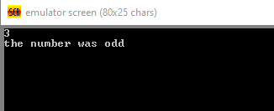

Task 2:
Code (TEXT):
.model small

.data

str1 db "Grade = A ",10,13,"$"
str2 db "Grade = B ",10,13,"$"
str3 db "Grade = C ",10,13,"$"
str4 db "Grade = F ",10,13,"$"
str5 db "Marks Are Not valid",10,13,"$"

msg1 db 101

.code

main:

mov ax, @data
mov ds, ax

cmp msg1, 100
JG notValid
cmp msg1, 0
JL notValid

cmp msg1, 90
JGE a

cmp msg1, 80
JGE b

cmp msg1, 50
JGE c

lea dx, str4
mov ah, 09
int 21h
JMP exit

notValid:
lea dx, str5
mov ah, 09
int 21h
JMP exit

a:
lea dx, str1
mov ah, 09
int 21h
JMP exit

b:
lea dx, str2
mov ah, 09
int 21h
JMP exit

c:
lea dx, str3
mov ah, 09
int 21h

exit:

mov ah, 4ch
int 21h

end main

Screenshot (CODE):
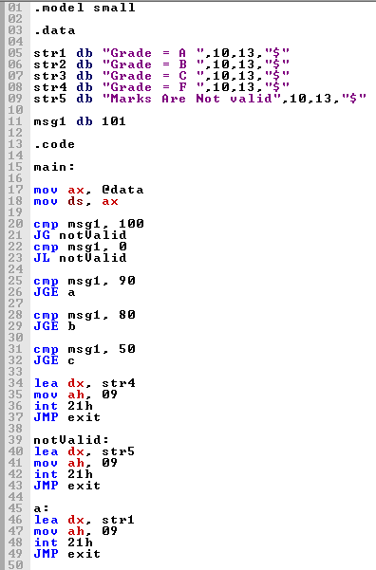
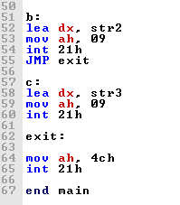

Screenshot (OUTPUT):
